**Public Service Awards**

The Rotary Club of Sandy Springs hosted the annual Public Safety Awards Luncheon on Monday, October 19, 2015, during which the City of Sandy Springs’ Fire, Police and EMS 2015 professionals of the year were recognized. Chief Keith Sanders, City of Sandy Springs Fire & Rescue, and Chief Kenneth DiSimone, City of Sandy Springs Police Department each presented the awards to their department honorees. City of Sandy Springs Mayor Rusty Paul, a Rotary Club of Sandy Springs member, spoke to attendees about the quality of the City of Sandy Springs’ Police and Fire/EMS Departments. During October, which is Vocational Service month for Rotary worldwide, the Rotary Club of Sandy Springs celebrates the City of Sandy Springs’ public service professionals by hosting the Annual Public Safety Awards, which recipients are chosen by the City of Sandy Springs Fire, EMS and Police Departments.2015 Winners are:  
  
2015 Chief Fire Officer of the Year - Division Commander Donald Willbanks  
2015 Paramedic of the Year - Firefighter Kevin Parks   
2015 Fire Fighter of the Year - Firefighter Daniel Fullmore  
2015 Fire Officer of the Year - Captain James Reeves  
2015 Police Officers of the Year - Officers Elizardo Rodriguez and Katrina Bruce  
2015 Police Supervisor of the Year - Sergeant Scott Levy  
2015 Police Employee of the Year - Kim Davis  
  
Pictured: l-r Police Department: City of Sandy Springs Police Department winners Officer Elizardo Rodriguez, Kim Davis, Officer Katrina Bruce, Chief Ken DiSimone, Sergeant Scott Levy, Rotary Club of Sandy Springs President Jerry Hicks

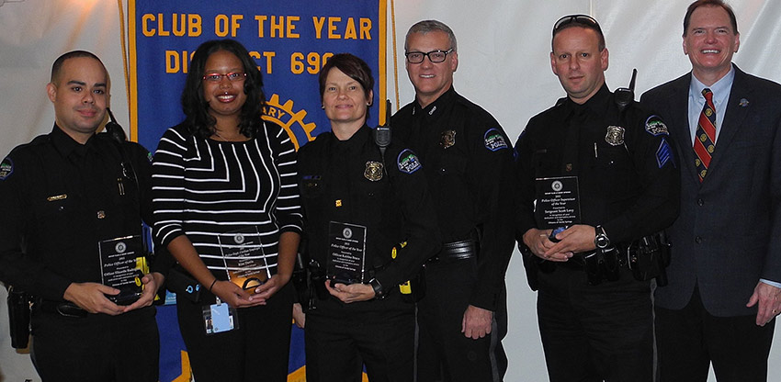

Photo City of Sandy Springs Fire/EMS Chief Keith Sanders, Firefighter Kevin Parks, Division Commander Donald Willbanks, Firefighter Daniel Fullmore, Captain James Reeves, Rotary Club of Sandy Springs President

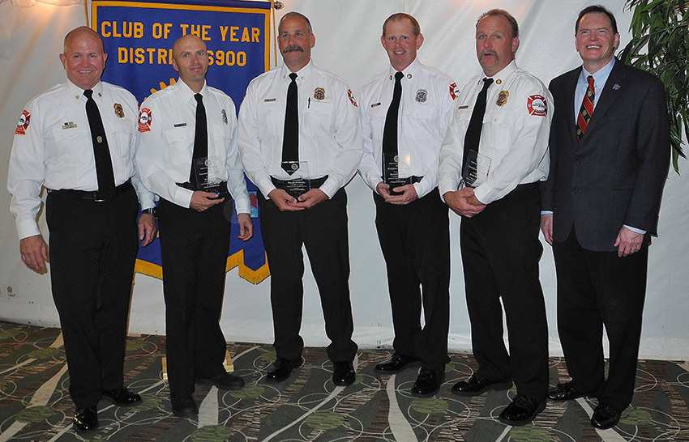

Ret. Chief Jack McElfish and Chief Keith Sanders

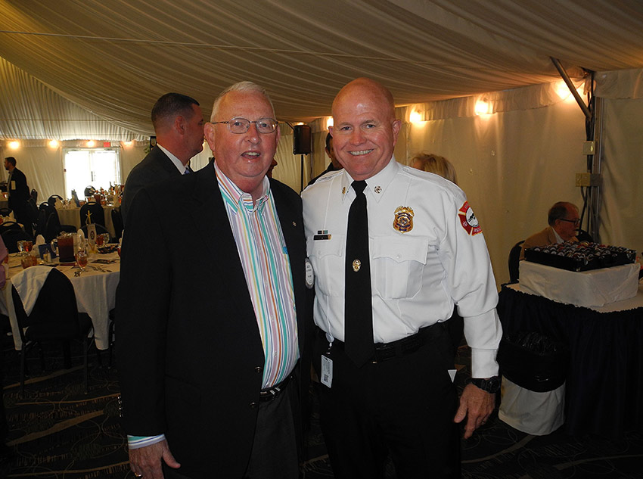

Mayor Rusty Paul

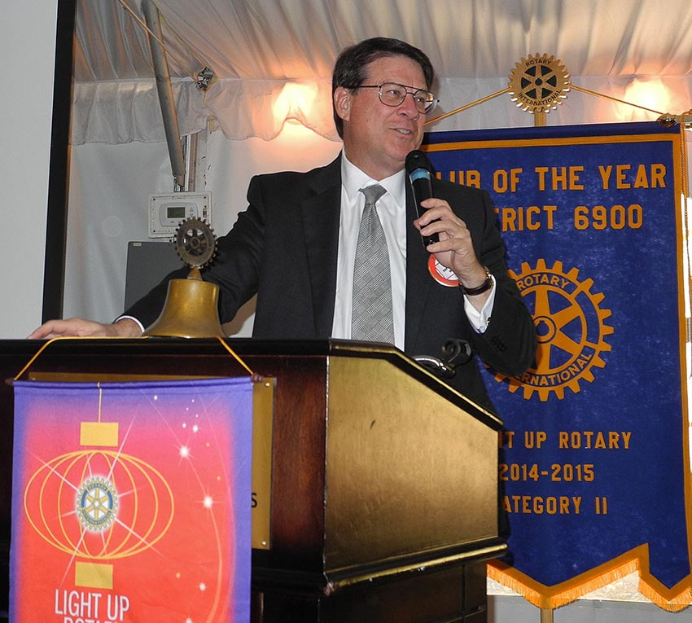

For more photos, go to <http://www.zenfolio.com/rotaryclubofsandysprings/e/p960124940>